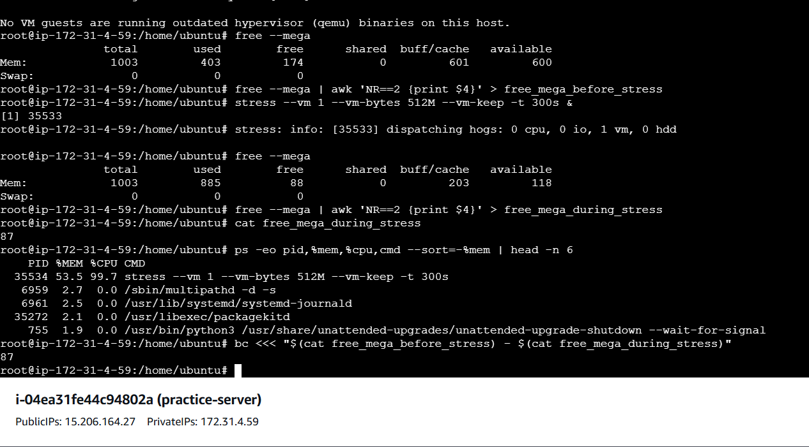

sudo yum update

3 sudo yum upgrade

4 dnf --help | grep list

5 dnf repolist

6 dnf list installed

7 dnf list installed | grep curl

8 dnf search mariab

9 dnf search mariadb

10 sudo dnf install mariadb105

11 dnf list installed | grep mariadb

12 sudo dnf remove mariadb105

13 dnf list installed | grep mariadb

14 dnf list installed

15 dnf check-upate

16 dnf check-update

17 sudo dnf config-manager --add-repo https://rpm.releases.hashicorp.com/AmazonLinux/hashicorp.repo

18 dnf list --showduplicates terraform

19 sudo dnf install terraform-1.6.0-1

20 sudo dnf install terraform-1.5.0-1 --allowerasing

21 dnf list --showduplicates terraform

22 sudo dnf update terraform

23 sudo dnf system-upgrade reboot

24 sudo dnf system-upgrade reboot

25 dnf install 'dnf-command(system-upgrade)

26 history

103 sudo systemctl show -p MainPID hello-world

104 sudo lsof -p $(pgrep httpd)

105 sudo lsof -p $(pgrep httpd.d)

106 history

107 sudo adduser mylinuxuser

108 sudo passwd -l mylinuxuser

109 sudo passwd mylinuxuser

110 su linuxuser

111 su mylinuxuser

112 su root

113 cd ../..

114 sudo ca etc/passwd

115 sudo cat etc/passwd

Bhanu Prakash left

U SAI BALA SUBRAMANYAM left